**MAKK**

**Banking and Money Transfer System**

**Analysis Class Report**

**Revision History**

|  |  |  |  |  |
| --- | --- | --- | --- | --- |
| **Authors** | **Description of Change** | **Sections** | **Rev** | **Date** |
| Kiren Syed | Analysis class diagram and list | All | 0 | 3/14/18 |
| Maxfield Wilhoite | Revised Class Descriptions and Revised Diagram | All | 1 | 3/20/18 |
| Maxfield Wilhoite | Updated Class Diagram and class methods | 2.1, 2.2.2 | 2 | 4/12/2018 |

**Table of Contents**

1 Team Description 4

2 Project Description 4

2.1 Analysis Class Diagram 5

2.2 Analysis Class List 6

2.2.1 UI 6

2.2.2 Controller 6

2.2.3 Account 7

2.2.4 Balance 7

2.2.5 Debit 8

# Team Description

|  |  |
| --- | --- |
| **Team Member Name** | **Email Address** |
| Maxfield Wilhoite | maxw@csu.fullerton.edu |
| Kiren Syed | kirensyed@csu.fulerton.edu |
| Alex Truong | Alexbt1992@csu.fullerton.edu |
| Kenny Chao | kchao@csu.fullerton.edu |
|  |  |
|  |  |

# Project Description

Statement of Purpose: Develop a secure and free banking program.

Detailed Description: Develop a banking system that allows users to deposit, withdraw, and transfer with ease. Allow users to obtain debit cards and loans from their account. Our team will implement a user login system that will allow them to access their bank account and be able to receive and transfer funds between accounts.

## Analysis Class Diagram

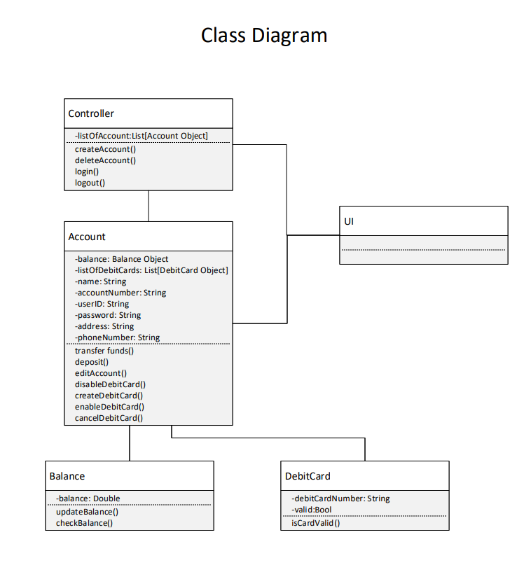

## Analysis Class List

|  |  |
| --- | --- |
| **Sequence Number** | **Analysis Class** |
| 1 | UI |
| 2 | Controller |
| 3 | Account |
| 4 | Balance |
| 5 | Debit |

### UI

Description: Presents a view to the user, interacts and retrieved information from the system through the controller class.

Methods:

Attributes:

### Controller

Description: Manages the list of all the accounts in the system. Handles account creation and logging in and out of the system.

Methods:

* createAccount()
* deleteAccount()
* login()
* logout()

Attributes:

* listOfAccounts: List[Account Object]

### Account

Description: Manages and holds are account related data. Manages the balance of an account and the debit cards of an account.

Methods:

* transferFunds()
* deposit()
* editAccount()
* createDebitCard()
* cancelDebitCard()
* enableDebitCard()
* cancelDebitCard()

Attributes:

* balance: Balance Object
* listOfDebitCards: List[DebitCard Object]
* name: String
* accountNumber: String
* userID: String
* password: String
* address: String
* phoneNumber: String

### Balance

Description: Holds the balance of an account and performs updates to the balance

Methods:

* updateBalance()
* checkBalance()

Attributes:

* balance: Double

### 2.2.5 Debit

Description: Holds the information about a debit card

Methods:

* isCardValid()

Attributes:

* debitCardNumber: String
* valid: Bool